**PART 1**

Result after running script provided: <https://www.up.ist.psu.edu/documentation/IST210/D3WgqIrD/FLIX2YOU_data_load.txt>

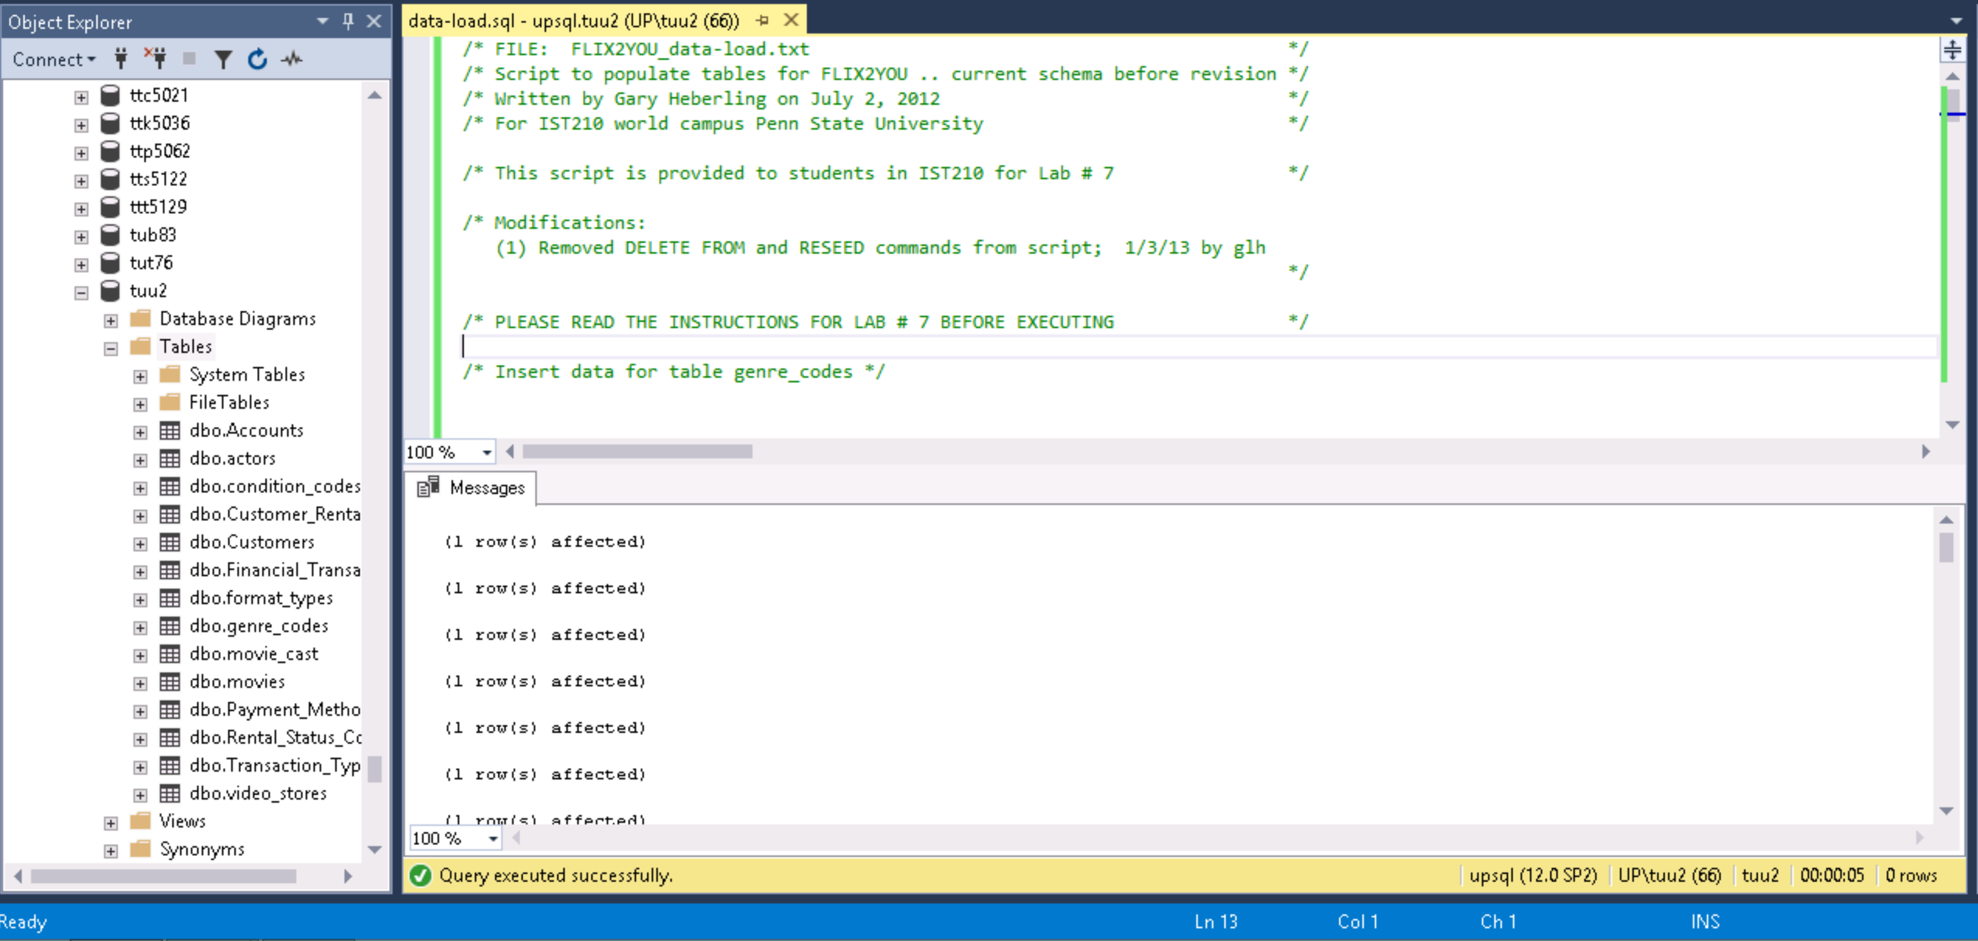

**PART 2**

The second part of the lab you will create a data dictionary for the remaining seven tables (right hand side of the FLIX2YOU ERD). The data dictionary can be a formatted Word document or an Excel spreadsheet file. Please follow the format of the sample data dictionary found in Chapter 3 of the textbook.

**PART 3**

**MAKING TABLES**

CREATE TABLE Customer_Rentals(

item_rental_id int IDENTITY (1,1) not null,

customer_id int not null,

movie_id int not null,

rental_status_code int not null,

rental_date_out date not null,

rental_date_returned date null,

rental_amount_due decimal(10,2) not null,

other_rental_details varchar(500) null)

Command(s) completed successfully.

CREATE TABLE Customers(

customer_id int Identity (1,1) not null,

member_yn int null,

membership_number int null,

date_became_member date not null,

customer_first_name varchar(30) not null,

customer_last_name varchar(30) not null,

customer_address varchar(100) not null,

customer_phone varchar(30) not null,

customer_email varchar(100) not null,

customer_dob date not null)

Command(s) completed successfully.

CREATE TABLE Financial_Transactions(

transaction_id int Identity (1,1) not null,

account_id int not null,

item_rental_id int not null,

previous_transaction_id int not null,

transaction_type_code int null,

transaction_date date null,

transaction_amount decimal (10,2) null,

transaction_comment varchar (100) null)

Command(s) completed successfully.

CREATE TABLE Accounts(

account_id int Identity (1,1) not null,

customer_id int not null,

payment_method_code int not null,

account_name varchar(100) not null,

account_details varchar(100) not null)

Command(s) completed successfully.

CREATE TABLE Rental_Status_Codes(

rental_status_code int Identity (1,1) not null,

rental_status_description varchar(100) not null)

Command(s) completed successfully.

CREATE TABLE Transaction_Types(

transaction_type_code int Identity (1,1) not null,

transaction_type_description varchar(100) not null)

Command(s) completed successfully.

CREATE TABLE Payment_Methods(

payment_method_code int identity (1,1) not null,

payment_method_description varchar(100) not null)

Command(s) completed successfully.

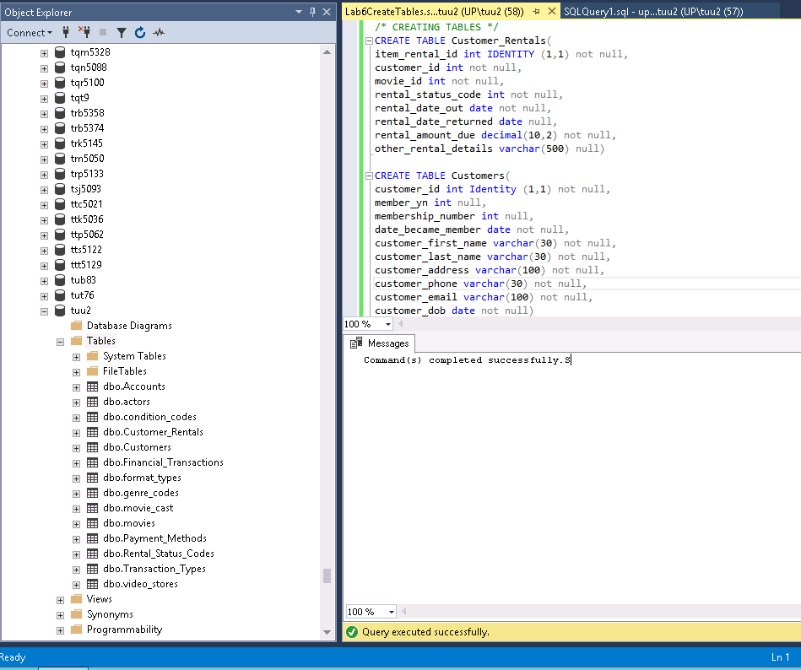

Primary Keys

Alter table Customer_Rentals add constraint pk_item_rental_id primary key(item_rental_id)

Alter table Customers add constraint pk_customer_id primary key(customer_id)

Alter table Financial_Transactions add constraint pk_transaction_id primary key(transaction_id)

Alter table Accounts add constraint pk_account_id primary key(account_id)

Alter table Rental_Status_Codes add constraint pk_rental_status_code primary key(rental_status_code)

Alter table Transaction_Types add constraint pk_transaction_type_code primary key (transaction_type_code)

Alter table Payment_Methods add constraint pk_payment_method_code primary key(payment_method_code)

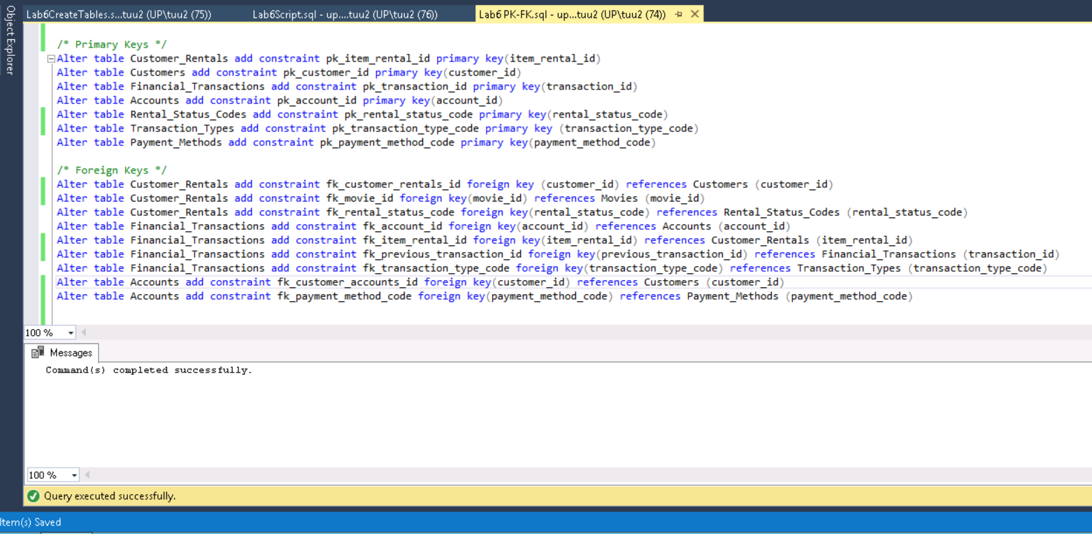

Foreign Keys

Alter table Customer_Rentals add constraint fk_customer_rentals_id foreign key (customer_id) references Customers (customer_id)

Alter table Customer_Rentals add constraint fk_movie_id foreign key(movie_id) references Movies (movie_id)

Alter table Customer_Rentals add constraint fk_rental_status_code foreign key(rental_status_code) references Rental_Status_Codes (rental_status_code)

Alter table Financial_Transactions add constraint fk_account_id foreign key(account_id) references Accounts (account_id)

Alter table Financial_Transactions add constraint fk_item_rental_id foreign key(item_rental_id) references Customer_Rentals (item_rental_id)

Alter table Financial_Transactions add constraint fk_previous_transaction_id foreign key(previous_transaction_id) references Financial_Transactions (transaction_id)

Alter table Financial_Transactions add constraint fk_transaction_type_code foreign key(transaction_type_code) references Transaction_Types (transaction_type_code)

Alter table Accounts add constraint fk_customer_accounts_id foreign key(customer_id) references Customers (customer_id)

Alter table Accounts add constraint fk_payment_method_code foreign key(payment_method_code) references Payment_Methods (payment_method_code)